Nashville Housing Market Analysis
  - 2013–2016

BY

EFE OBUKOHWO

Data Analyst Portfolio Project — Excel Workbook Report

Table of Contents
1. Executive Summary 4
2. Project Background and Objectives 4
Business Problem 4
Project Goals 4
Key Questions 4
3. Dataset Overview 5
Dataset Description 5
Data Structure 5
Initial Data Assessment 5
4. Data Cleaning and Preparation 5
Handling Missing Values 5
Standardizing Date Formats 5
Address Parsing and Transformation 5
Duplicate Record Removal 6
Data Validation 6
5. Excel Analysis Methodology 6
VLOOKUP Implementation 6
XLOOKUP Implementation 6
INDEX/MATCH Analysis 6
Conditional Calculations 6
KPI Development 6
6. Exploratory Data Analysis 7
Property Sales Distribution 7
Property Value Analysis 7
Vacancy Analysis 7
Geographic Trends 7
Time-Based Trends 7
7. Pivot Table Analysis 7
Average Sale Price by City 7
Sales Volume by Year 8
Total Sales by Location (Top 10) 8
Property Category Analysis 9
Vacant vs Occupied Properties 9
8. Data Visualization 9
Housing Price Trends 9
Sales Performance by City 10
Property Category Distribution 12
Vacancy Analysis Charts 12
Monthly Seasonality 13
9. Interactive Dashboard 14
Dashboard Overview 14
Key Performance Indicators (KPIs) 17
Slicers and Filters 17
Dashboard Insights 17
10. Key Findings and Insights 17
11. Business Recommendations 18
12. Conclusion 18
13. Skills Demonstrated 18
14. Appendix 19
Formula Reference 19
Data Dictionary 19
Dashboard Screenshots 20

1. Executive Summary
This project transforms a raw, 56,636-row Nashville property-sales export into a fully analyzed, interactive Excel decision tool. After cleaning (removing 168 duplicate transactions and standardizing dates, values, and flags), 56,468 verified sales remained, spanning 2013 through 2016. The market moved $2,783,758,501 in total sales value in 2013, climbing to a $6,708,760,110 peak in 2015; a 52.0% increase in dollar volume and 24.0% growth in transaction count over the period. The typical home sold for a median of $205,838 (average $327,581), and 8.6% of properties sold vacant. Nashville proper dominates, concentrating $14.73B of the $18.50B total — roughly 80% of all sales value. The market is predominantly mid-market: 32,826 of 56,468 sales fell in the $100K–$300K band.

2. Project Background and Objectives

Business Problem
Raw municipal housing data is unusable for decision-making in its delivered state — it contains duplicate transactions, missing valuations, inconsistent formatting, and no derived metrics. Stakeholders need a clean, queryable, visual tool that answers where value is concentrated and how the market is trending.

Project Goals
- Produce a single clean master table of Nashville sales.
- Demonstrate professional Excel technique (lookups, conditional aggregation, KPIs).
- Summarize the market with pivot tables and charts.
- Deliver an interactive dashboard that filters every KPI and chart at once.

Key Questions
- Where are the most valuable properties, and which cities drive the market?
- Are prices rising or falling over time, and is there seasonality?
- How many properties sell vacant?
- What price segment dominates?

3. Dataset Overview

Dataset Description
The dataset is the public Nashville Housing dataset covering sales from 2013–2016, delivered as a single sheet of 56,636 rows × 31 columns.

Data Structure
The cleaned master table (Cleaned_Data, Excel Table SalesData) retains 17 business columns plus a helper column: UniqueID, ParcelID, SaleDate, SaleYear, SaleMonth, SalePrice, PropertyStreet, PropertyCity, OwnerStreet, OwnerCity, SoldAsVacant, LandValue, BuildingValue, TotalValue, plus three calculated columns (Property Value Group, Price Category, Vacant Status) and a Visible helper.

Initial Data Assessment
- 168 exact-duplicate transactions identified for removal.
- 30,619 rows lacked assessor valuation (Land/Building/Total Value) and owner details — retained, but flagged “N/A” in the value-group column so they never distort value tiers.
- 159 rows had a blank property city/street.
- SaleDate arrived as an Excel serial number requiring date formatting.

4. Data Cleaning and Preparation

Handling Missing Values
Rows missing assessor valuations were kept (their sale data is complete and valid) but guarded: the Property Value Group formula returns “N/A” when TotalValue is blank rather than mis-classifying a $0 value as “Low Value”. Sale-based analysis therefore uses all 56,468 rows, while value-tier analysis cleanly excludes unvalued rows.

Standardizing Date Formats
SaleDate (stored as a serial) was formatted mm/dd/yyyy, and two derived columns were added with formulas: SaleYear =YEAR(SaleDate) and SaleMonth =MONTH(SaleDate).

Address Parsing and Transformation
Property city was already delivered as a discrete column, so no address-string splitting was required. Standardization instead focused on trimming and consistent casing of the city field and confirming the SoldAsVacant flag was uniform Yes/No.

Duplicate Record Removal
168 duplicate sales (matching on ParcelID + SaleDate + SalePrice + PropertyStreet) were removed, reducing 56,636 rows to 56,468 unique transactions.

Data Validation
Post-clean checks confirmed: SalePrice fully populated (lowest $50); no error values across derived columns; SaleDate range within 2013–2016; category and vacancy fields resolve to expected discrete values.

5. Excel Analysis Methodology

VLOOKUP Implementation
A Property Category lookup table (thresholds 0 / 100,000 / 300,000 — Budget / Mid Market / Premium) drives an approximate-match lookup: =VLOOKUP(B9,$M$3:$N$5,2,TRUE).

XLOOKUP Implementation
Owner city is retrieved from a ParcelID input: =XLOOKUP($B$5,Cleaned_Data!B:B,Cleaned_Data!J:J,"Not found").

INDEX/MATCH Analysis
Sale price by ParcelID: =INDEX(Cleaned_Data!F:F,MATCH($B$5,Cleaned_Data!B:B,0)).

Conditional Calculations
- Average price of vacant homes (AVERAGEIFS): $298,772
- Total assessed value, Nashville (SUMIFS): $5,293,743,257
- Sales in 2015 (COUNTIFS): 16,794
- Premium-property count (COUNTIFS): 16,501

KPI Development
Workbook KPIs use SUM/AVERAGE/MAX/MIN/COUNT; the dashboard uses filter-aware SUBTOTAL equivalents so cards respond to slicers:
KPI | Value
Total Sales Value | $18,497,820,434
Average Sale Price | $327,581
Median Sale Price | $205,838
Highest Sale | $54,278,060
Lowest Sale | $50
Property Count | 56,468
% Sold Vacant | 8.6%

6. Exploratory Data Analysis

Property Sales Distribution
56,468 sales; median $205,838 vs. average $327,581 — the gap signals a right-skewed market with a long tail of high-value transactions (top sale $54,278,060).

Property Value Analysis
Among valued rows: average land $69,157, average building $173,228, average total $232,564. Land represents 29.7% of total assessed value.

Vacancy Analysis
Occupied 51,588 vs. Vacant 4,880 — 8.6% of sales were vacant.

Geographic Trends
Value is highly concentrated: Nashville alone is $14.73B, with Antioch ($1,588.6M) and Hermitage ($623.8M) a distant second and third.

Time-Based Trends
Peak sales year: 2015. Busiest month: Jun. Sales rose from 11,338 (2013) to 16,794 (2015) before easing to 14,055 (2016).

7. Pivot Table Analysis

Average Sale Price by City
City | Avg Sale Price | Total Sales | Sales Count
Antioch | $252,837 | $1,588,577,771 | 6,283
Bellevue | $25,000 | $25,000 | 1
Brentwood | $312,164 | $528,805,672 | 1,694
Franklin | $150,000 | $150,000 | 1
Goodlettsville | $289,799 | $212,712,451 | 734
Hermitage | $199,885 | $623,840,300 | 3,121
Joelton | $143,239 | $1,575,631 | 11
Madison | $136,455 | $287,782,670 | 2,109
Mount Juliet | $243,490 | $43,828,234 | 180
Nashville | $366,715 | $14,730,582,390 | 40,169
Nolensville | $287,144 | $141,848,998 | 494
Old Hickory | $191,152 | $270,289,371 | 1,414
Unknown | $298,000 | $298,000 | 1
Whites Creek | $168,434 | $16,338,123 | 97

Sales Volume by Year
Year | Sales Count | Total Value
2013 | 11,338 | $2,783,758,501
2014 | 14,281 | $4,772,768,472
2015 | 16,794 | $6,708,760,110
2016 | 14,055 | $4,232,533,351

Total Sales by Location (Top 10)
Rank | City | Total Sales Value
1 | Nashville | $14,730,582,390
2 | Antioch | $1,588,577,771
3 | Hermitage | $623,840,300
4 | Brentwood | $528,805,672
5 | Madison | $287,782,670
6 | Old Hickory | $270,289,371
7 | Goodlettsville | $212,712,451
8 | Nolensville | $141,848,998
9 | Mount Juliet | $43,828,234
10 | Whites Creek | $16,338,123

Property Category Analysis
Category | Sales Count
Budget (<$100K) | 7,141
Mid Market ($100K–$300K) | 32,826
Premium (≥$300K) | 16,501

Vacant vs Occupied Properties
Status | Count
Occupied | 51,588
Vacant | 4,880

8. Data Visualization

Housing Price Trends
A yearly line chart shows volume rising to the 2015 peak then softening in 2016; a monthly column chart reveals a clear spring/summer selling season.
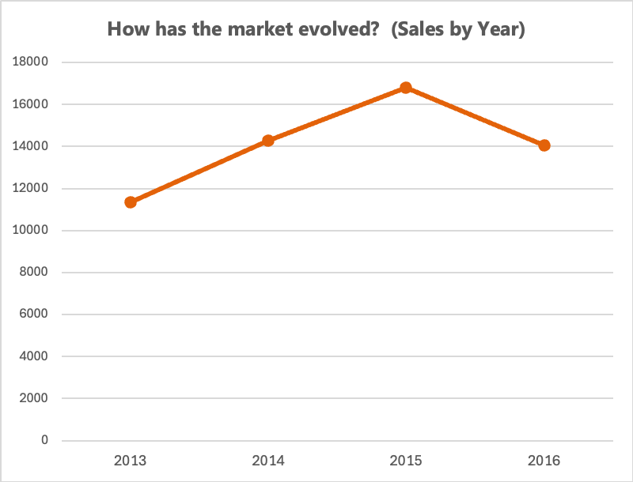
Figure 1 — Sales Volume by Year

Sales Performance by City
Horizontal bar charts rank cities by average price and by total sales value (Top 10), both making Nashville's dominance immediately visible.
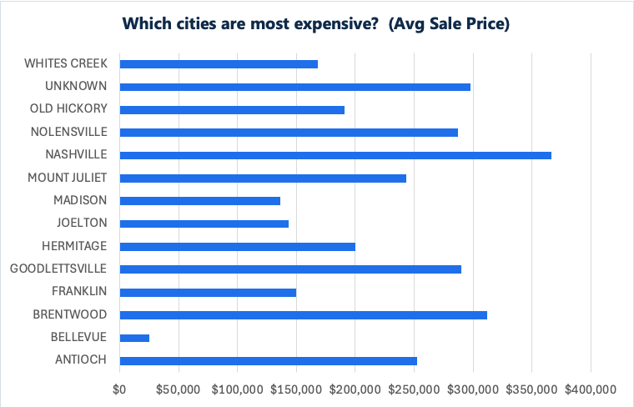
Figure 2 — Average Sale Price by City
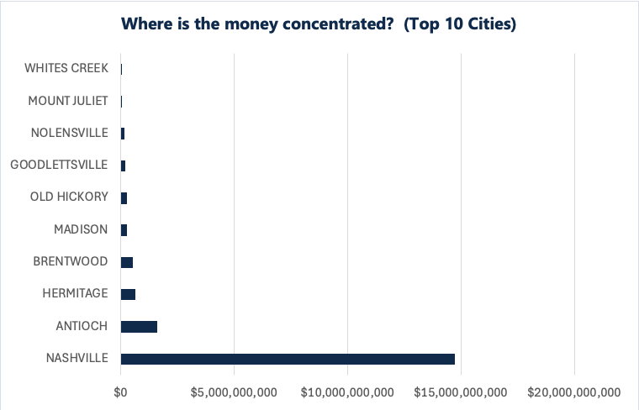
Figure 3 — Top 10 Cities by Sales Value

Property Category Distribution
A column chart shows mid-market homes (32,826) far outnumbering budget (7,141) and premium (16,501).
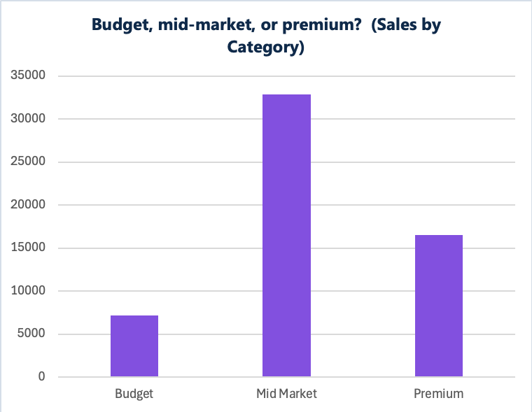
Figure 4 — Property Category Distribution

Vacancy Analysis Charts
A doughnut chart splits Occupied vs Vacant (8.6% vacant).
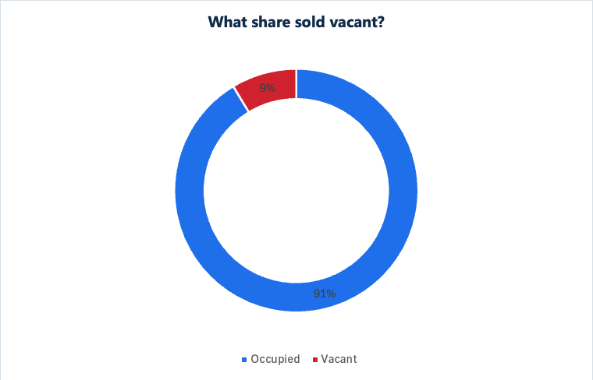
Figure 5 — Vacant vs Occupied

Monthly Seasonality
Month | Sales Count
Jan | 3,226
Feb | 2,678
Mar | 4,481
Apr | 5,233
May | 5,963
Jun | 6,616
Jul | 5,472
Aug | 5,615
Sep | 5,438
Oct | 4,832
Nov | 3,131
Dec | 3,783

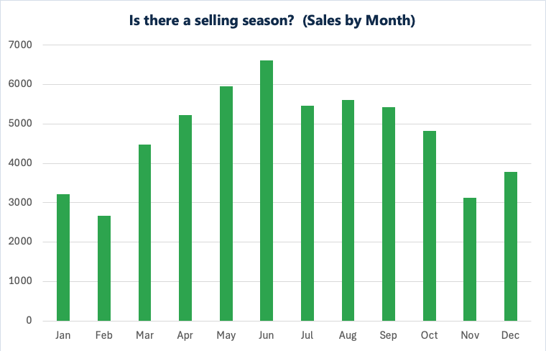
Figure 6 — Sales by Month (Seasonality)

9. Interactive Dashboard

Dashboard Overview
The Interactive_Dashboard sheet presents a navy title banner, five KPI cards, and a 2×3 grid of charts, all driven by a filter-aware calculation engine (Dashboard_Data). The full chart grid is reproduced below.

Figure 7 — Average Sale Price by City

Figure 8 — Top 10 Cities by Sales Value

Figure 9 — Sales Volume by Year

Figure 10 — Sales by Month (Seasonality)

Figure 11 — Vacant vs Occupied

Figure 12 — Property Category Distribution

Key Performance Indicators (KPIs)
Total Sales $18.50B · Average Price $327,581 · Highest Sale $54.3M · Property Count 56,468 · % Vacant 8.6%. Each card uses SUBTOTAL so it recalculates under any filter.

Slicers and Filters
Four slicers — Sale Year, Property City, Vacant Status, Price Category — are bound to the SalesData table. Because a Visible helper column (=SUBTOTAL(103,[@UniqueID])) feeds SUMPRODUCT summaries, every slicer filters all five KPIs and all six charts simultaneously (verified: selecting 2015 → $6.71B / 16,794 sales).

Dashboard Insights
Filtering by city, year, vacancy, or price band lets a reviewer instantly isolate, e.g., Nashville 2016 premium sales, and watch every visual update together — turning a static export into a live decision tool.

10. Key Findings and Insights

- Value is concentrated in Nashville — ~80% of all sales dollars.
- The market grew strongly then cooled — +52.0% value from 2013 to the 2015 peak, easing in 2016.
- Mid-market dominates — 58% of sales are $100K–$300K.
- Vacancy is modest — 8.6% of sales were vacant.
- Clear seasonality — sales peak in Jun and trough in winter.

11. Business Recommendations
- Prioritize Nashville and Antioch for inventory and marketing spend — that is where dollar volume lives.
- Time listings for spring/summer to capture peak demand.
- Target the mid-market band for the broadest buyer pool; treat premium (16,501 sales) as a specialized segment.
- Monitor the 2016 softening as a possible turning point before committing to aggressive acquisition.

12. Conclusion
The project demonstrates a complete analyst workflow — from a messy 56,636-row export to a validated 56,468-row master table, layered analysis, and a fully interactive dashboard — answering every stakeholder question with traceable, formula-driven evidence.

13. Skills Demonstrated
- Data Cleaning: de-duplication, missing-value strategy, date/flag standardization, validation.
- Data Analysis: conditional aggregation (SUMIFS/COUNTIFS/AVERAGEIFS), descriptive statistics, growth and seasonality analysis.
- Lookup Functions: VLOOKUP, XLOOKUP, INDEX/MATCH.
- Pivot Tables: nine pivots including a Top-N value filter and a two-dimensional Year×Vacant matrix.
- Dashboard Development: KPI cards, cross-filtering slicers, filter-aware SUBTOTAL/SUMPRODUCT engine.
- Data Storytelling: chart titles framed as business questions; a narrative from cleaning to recommendation.

14. Appendix

Formula Reference
Purpose | Formula
Sale year | =YEAR(SaleDate)
Price category | =IF(SalePrice<100000,"Budget",IF(SalePrice<300000,"Mid Market","Premium"))
Value group | =IF(TotalValue="","N/A",IF(TotalValue<100000,"Low Value",IF(TotalValue<300000,"Mid Value","High Value")))
Vacant status | =IF(SoldAsVacant="Yes","Vacant","Occupied")
VLOOKUP category | =VLOOKUP(B9,$M$3:$N$5,2,TRUE)
XLOOKUP owner city | =XLOOKUP($B$5,Cleaned_Data!B:B,Cleaned_Data!J:J,"Not found")
INDEX/MATCH price | =INDEX(Cleaned_Data!F:F,MATCH($B$5,Cleaned_Data!B:B,0))
Filter-aware KPI | =SUBTOTAL(109,SalesData[SalePrice])
Visible flag | =SUBTOTAL(103,[@UniqueID])
Filter-aware group sum | =SUMPRODUCT((SalesData[PropertyCity]=City)*SalesData[Visible]*SalesData[SalePrice])

Data Dictionary
Column | Description
UniqueID | Sequential record identifier
ParcelID | County parcel number (lookup key)
SaleDate / SaleYear / SaleMonth | Transaction date and derived parts
SalePrice | Transaction price (USD)
PropertyStreet / PropertyCity | Property location
OwnerStreet / OwnerCity | Owner mailing location
SoldAsVacant / Vacant Status | Vacancy flag (Yes/No → Vacant/Occupied)
LandValue / BuildingValue / TotalValue | Assessor valuations (USD)
Property Value Group | Low/Mid/High/N/A by TotalValue
Price Category | Budget/Mid Market/Premium by SalePrice

Dashboard Screenshots
Full-resolution screenshots of the six dashboard charts, provided for reference.

Figure 13 — Average Sale Price by City

Figure 14 — Top 10 Cities by Sales Value

Figure 15 — Sales Volume by Year

Figure 16 — Sales by Month (Seasonality)

Figure 17 — Vacant vs Occupied

Figure 18 — Property Category Distribution

